Lesson 07 Demo 01

Configuring Deploy Plugin for Performing Automated CD
Objective: To configure a CI/CD pipeline in Jenkins for deploying a Java application to Tomcat Apache

Tools required: GitHub, Jenkins, and Tomcat Apache

Prerequisites: You need to have a Jenkins up and running.

Steps to be followed:
- Install Tomcat Apache 9 on Ubuntu VM
- Log in to the Jenkins CI tool and install the Deploy to container plugin
- Configure the deployment stage in the Jenkins pipeline

Step 1: Install Tomcat Apache 9 on Ubuntu VM

- Open the terminal in your lab and use the following command to switch to the root user:
sudo su

- Install Tomcat Apache and other required packages using the following command:
apt update
apt install tomcat9 tomcat9-admin

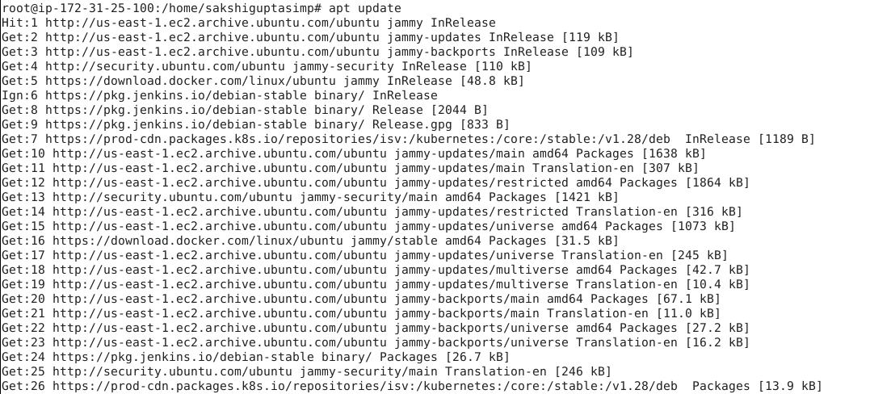

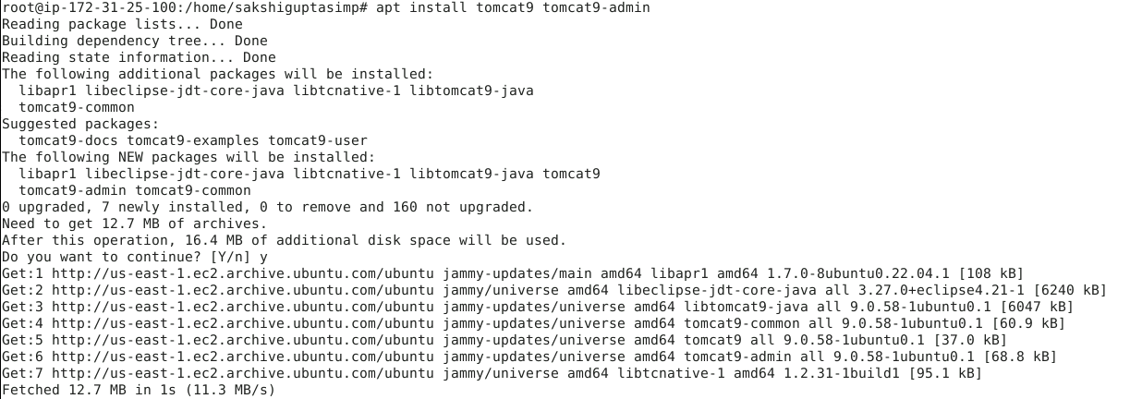

- Once the installation is complete, open the tomcat-users.xml file using the following command:
vi /etc/tomcat9/tomcat-users.xml

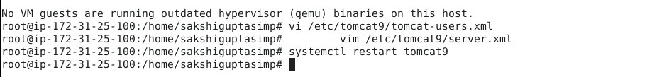

- Add the following content in tomcat-users.xml file:
<user username="tomcat" password="password" roles="admin-gui,manager-gui,manager-script"/>

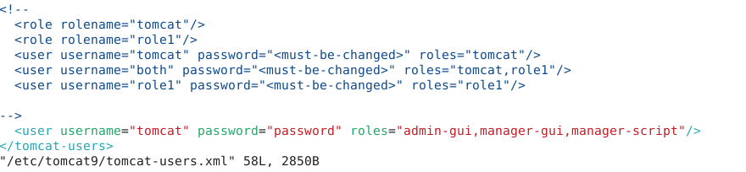

Note: To save the file and exit, press Esc, then type :wq, and press Enter

- Open the server.xml file using the following command and scroll down to change the connector port number of Tomcat to 9090:
vim /etc/tomcat9/server.xml

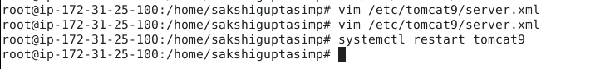

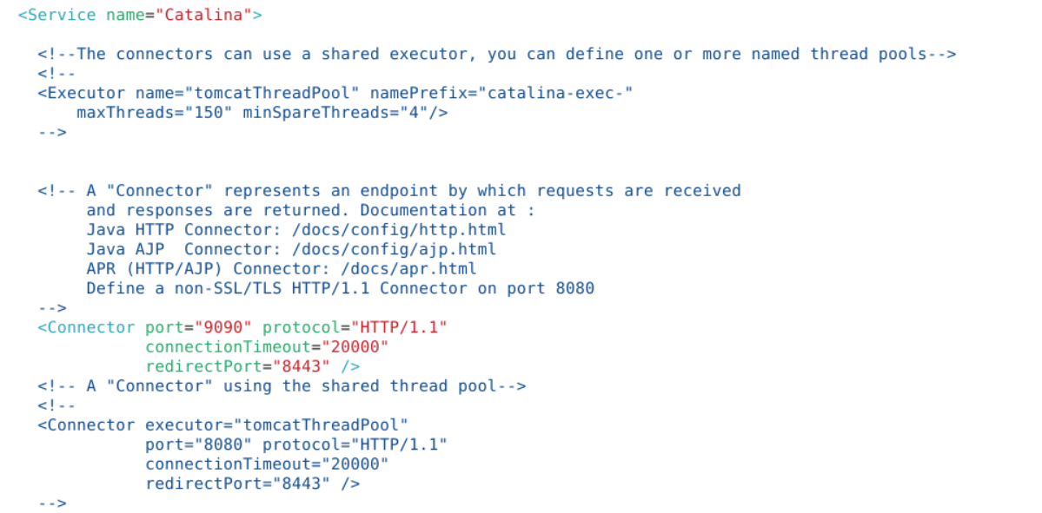

Note: To save the file and exit, press Esc, then type :wq, and press Enter

- Restart Tomcat using the following command:

RUN FOLLOWING COMMANDS

sudo nano /etc/default/tomcat9

add following line in this file

JAVA_HOME=/usr/lib/jvm/java-21-openjdk-arm64

And then run following commands

sudo systemctl daemon-reexec
sudo systemctl daemon-reload
sudo systemctl restart tomcat9
sudo systemctl status tomcat9

- Navigate to localhost:9090 in your web browser and access Tomcat

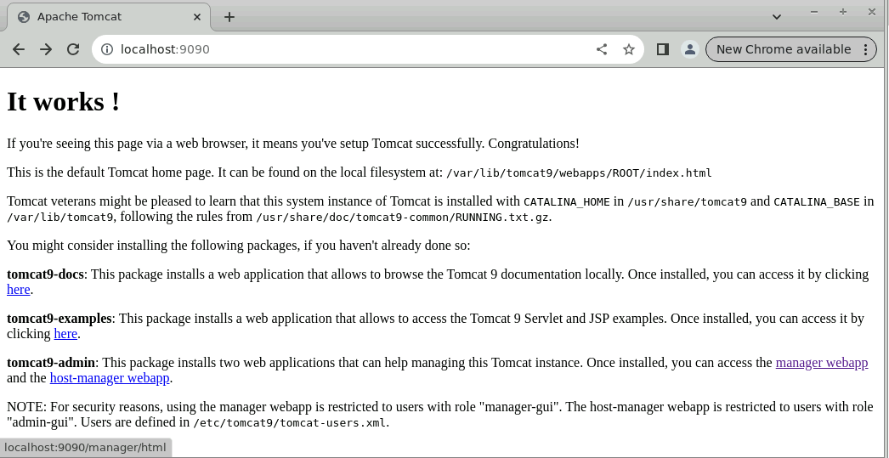

- Click and access manager webapp to make sure the Tomcat setup is complete

- Enter the credentials and click on Sign in

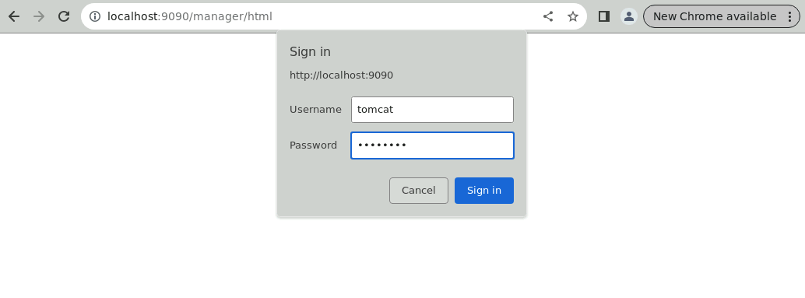
Note: The credentials for accessing Tomcat manager web app are
Username: tomcat and Password: password.

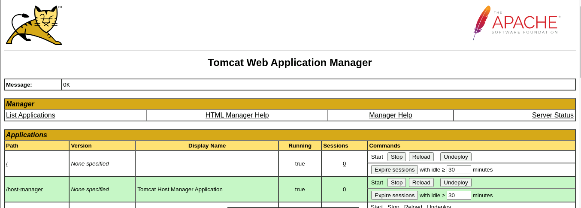

Step 2: Log in to Jenkins CI tool and install Deploy to container plugin

- Navigate to localhost:8080 in your web browser, enter your credentials, and click on Sign in

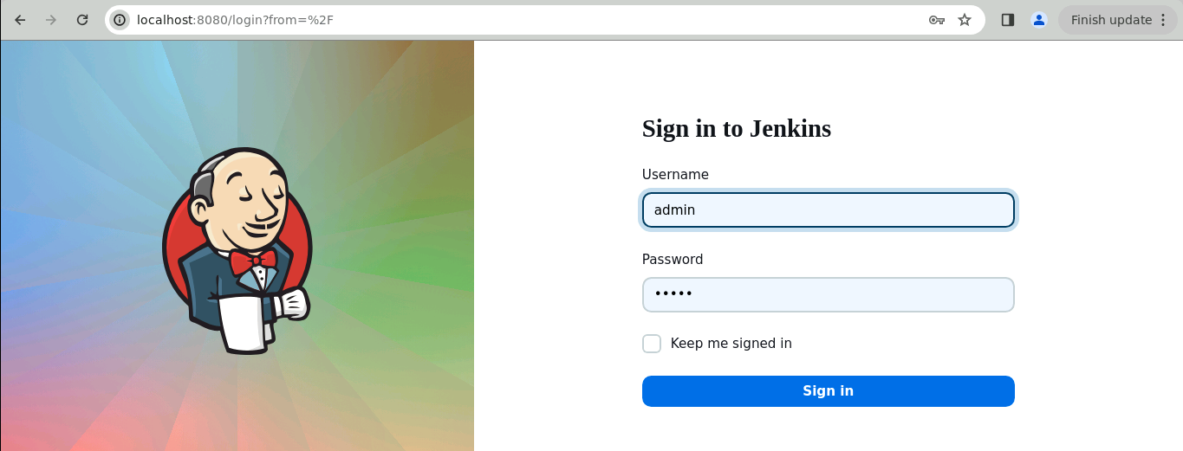
Note: The credentials for accessing Jenkins in the lab are Username: admin and Password: admin.

- Click on Manage Jenkins on the Jenkins dashboard

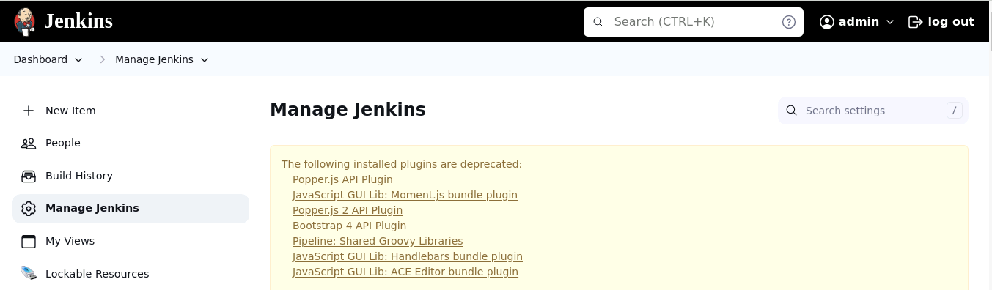

- Scroll down and click on Plugins under System Configuration

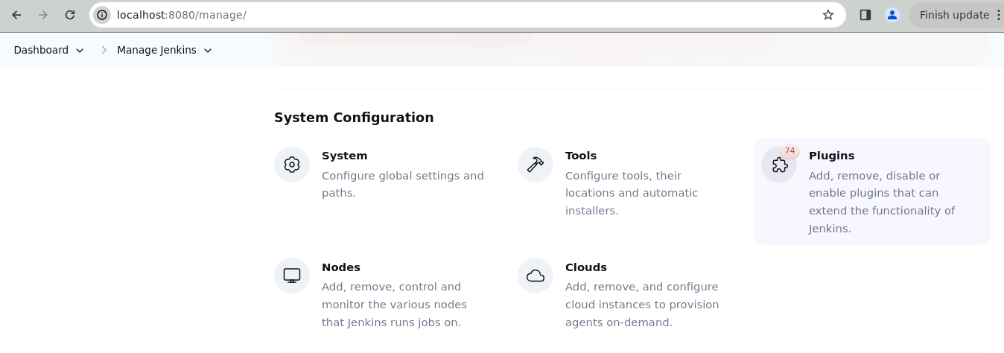

- Navigate to Available plugins and search for Deploy to container plugin

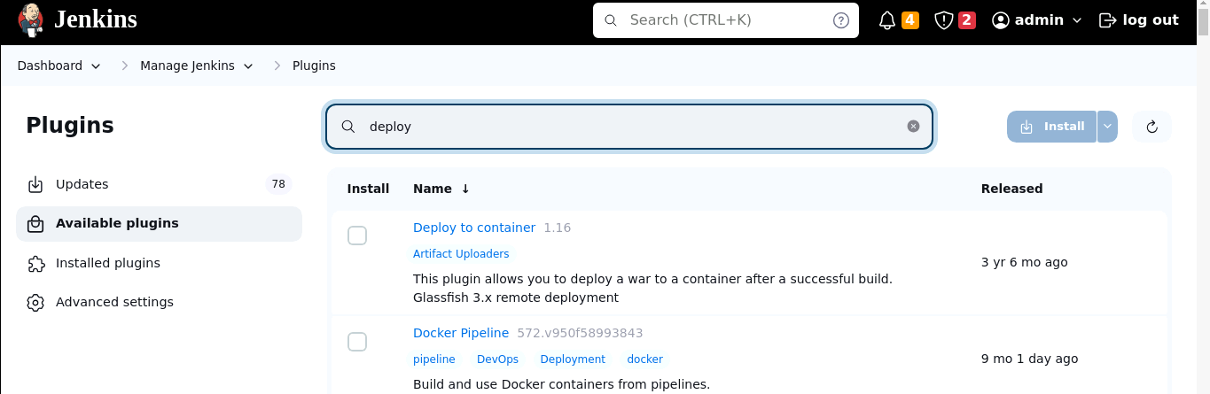

- Select Deploy to container plugin, click on Install

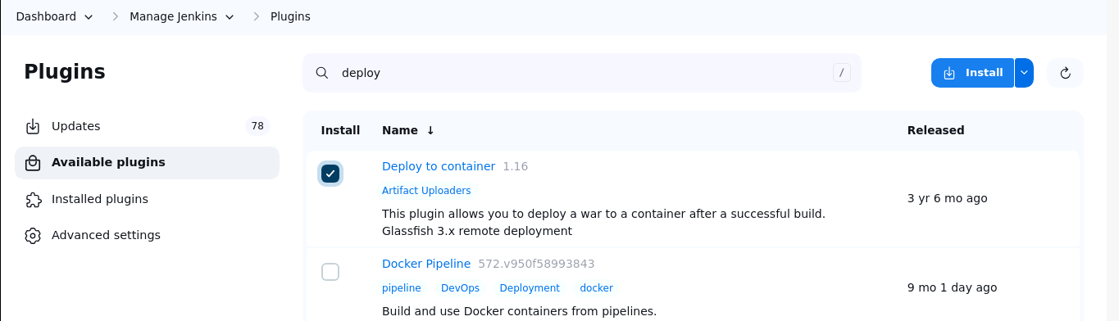

- After installation, navigate to the following URL to restart Jenkins:
http://localhost:8080/restart



Step 3: Configure the deployment stage in the Jenkins pipeline

- Enter your credentials and Sign in to Jenkins CI tool

Note: The credentials for accessing Jenkins in the lab are Username: admin and Password: admin.

- Click on New Item to create new Jenkins job

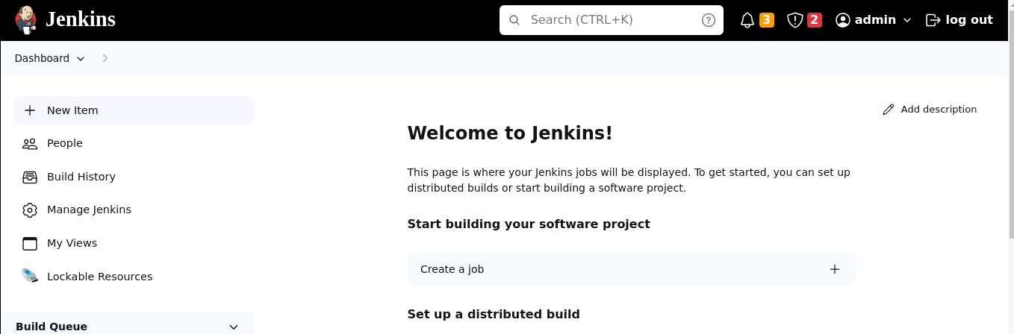

- Select Freestyle project while creating Jenkins job and provide a custom job name, then click on OK to continue

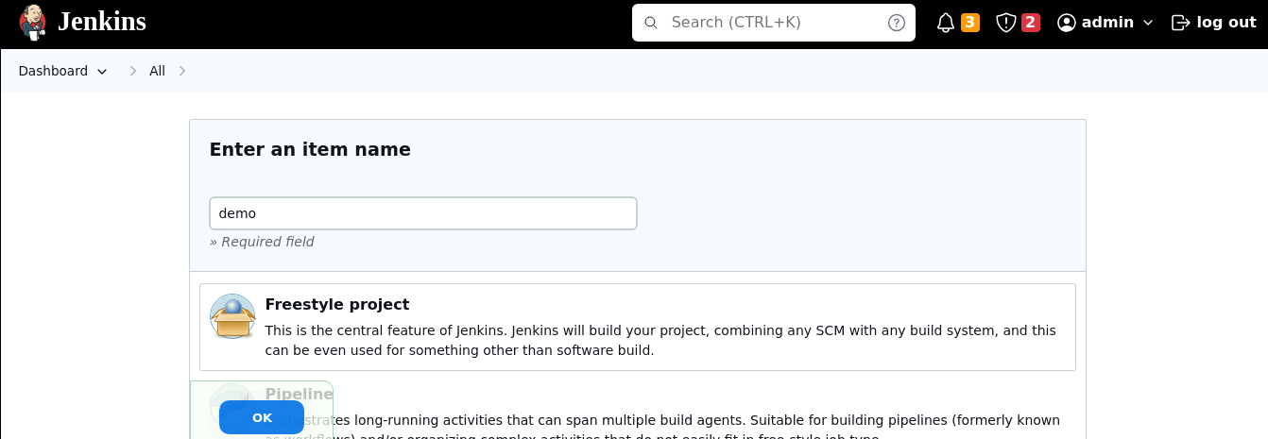

- Go to Source Code Management and select Git

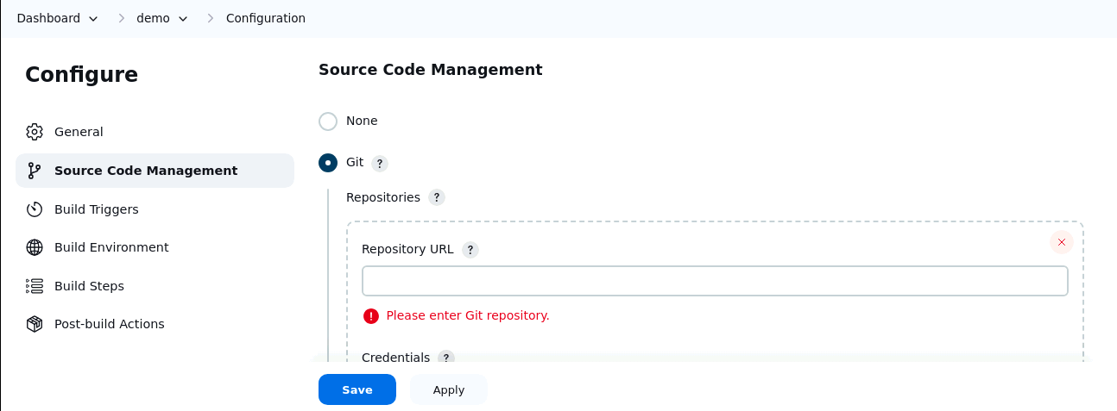

- Enter the following Repository URL:
https://github.com/hkshitesh/MavenBuild.git

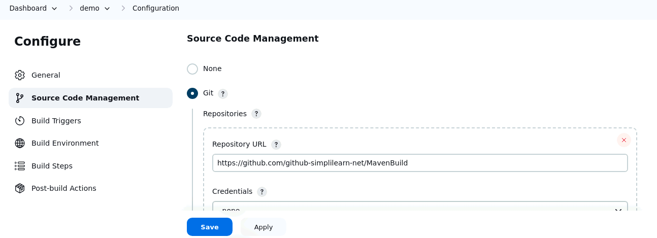

- Go to Build Steps under Configure:

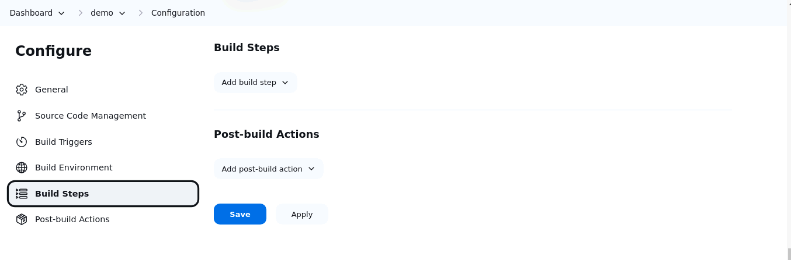

- Click on Add build step and select Invoke top-level Maven targets

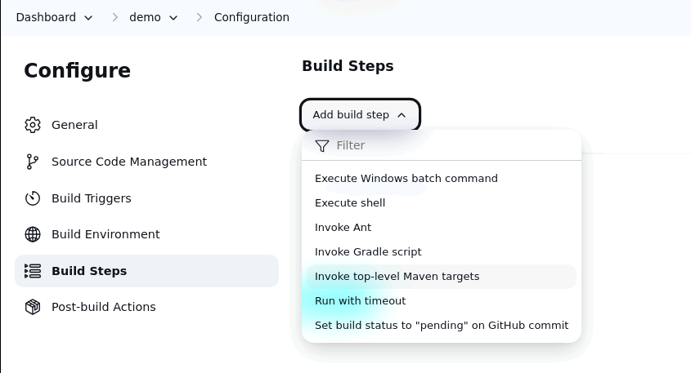

- Enter the following Maven Version:
mymaven

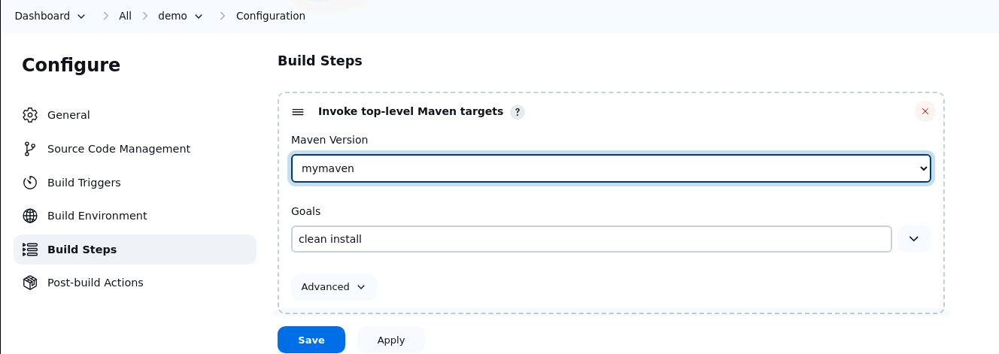

- Enter the following Goals:
clean install

- Go to Post-build Actions

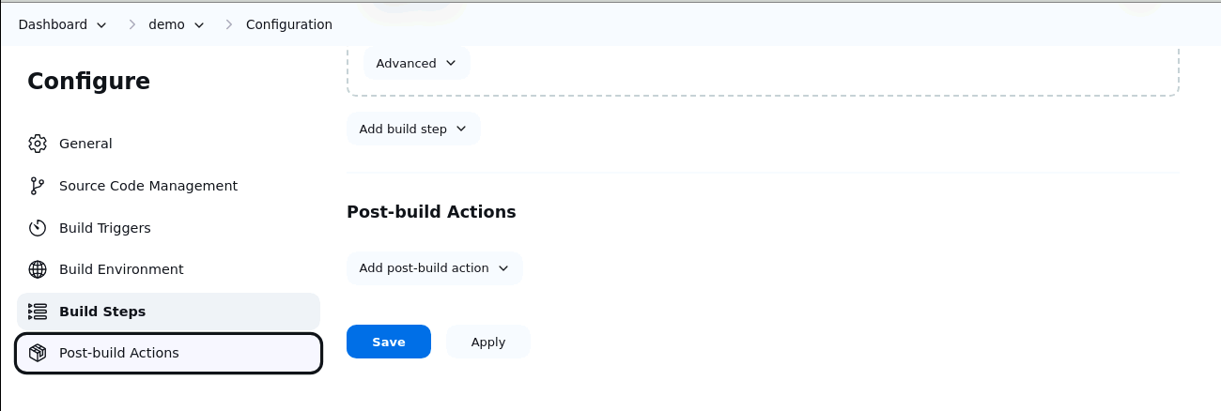

- Click on Add post-build action and select Deploy war/ear to a container

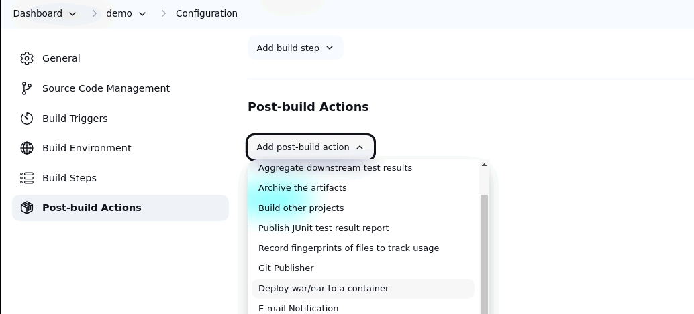

- Enter the following path under WAR/EAR files:
**/*.war

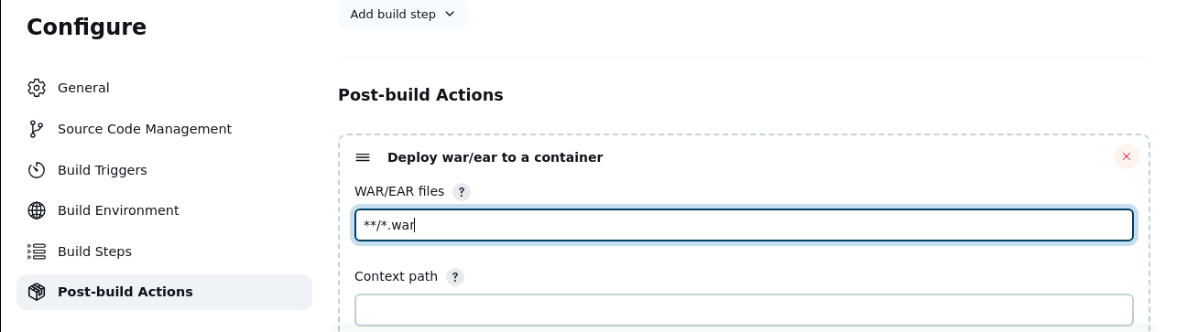

- Click on Add Container and select Tomcat 9.x Remote

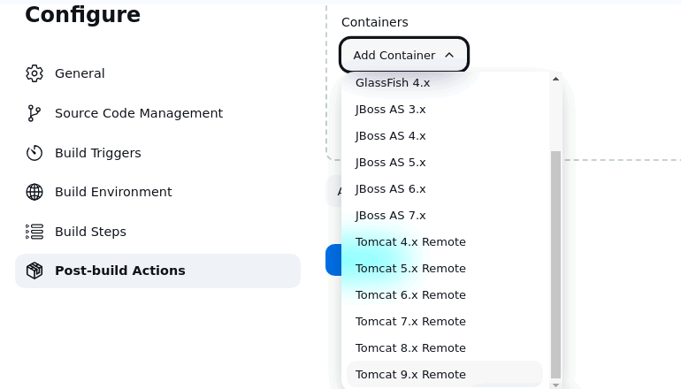

- Click on Add under Credentials and select Jenkins to add the Tomcat credentials

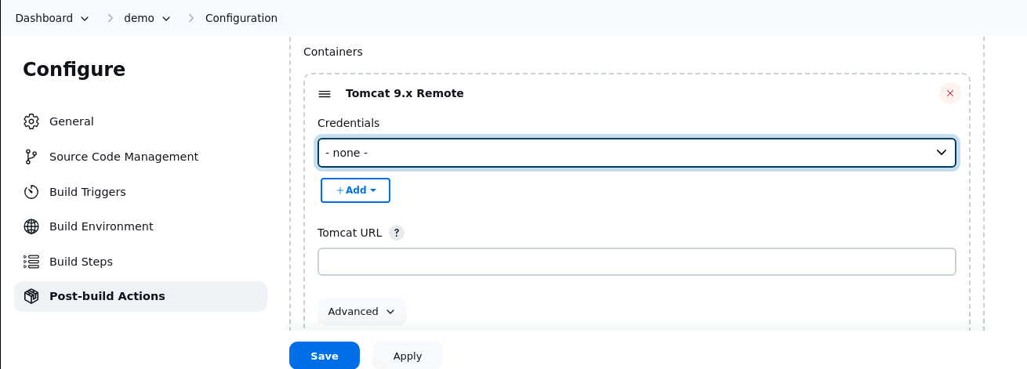

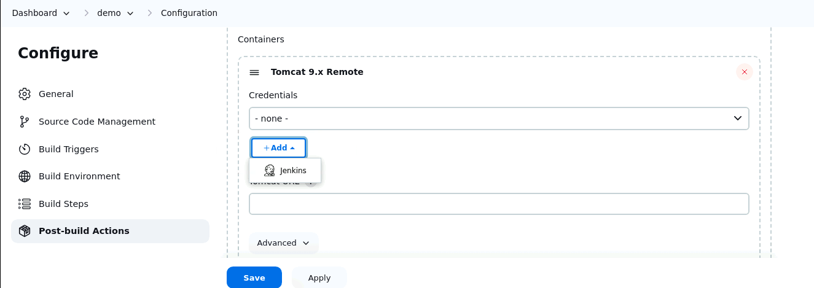

- Scroll down and enter the following details:
Username: tomcat
Password: password
ID: tomcat-id
Description: tomcat-id

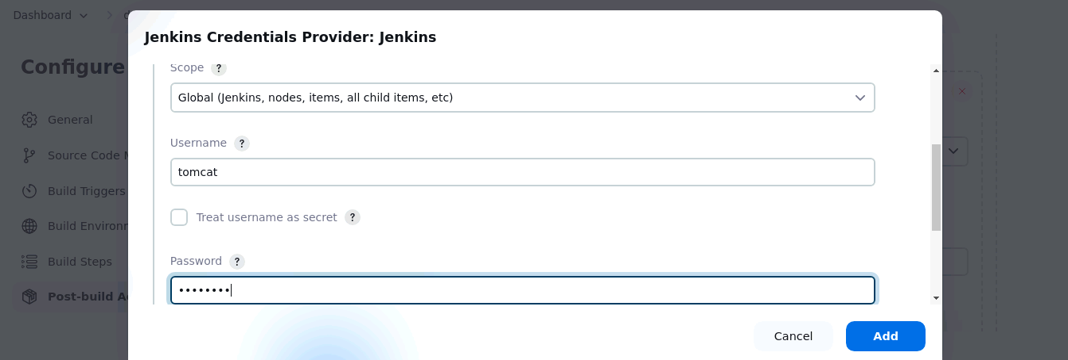

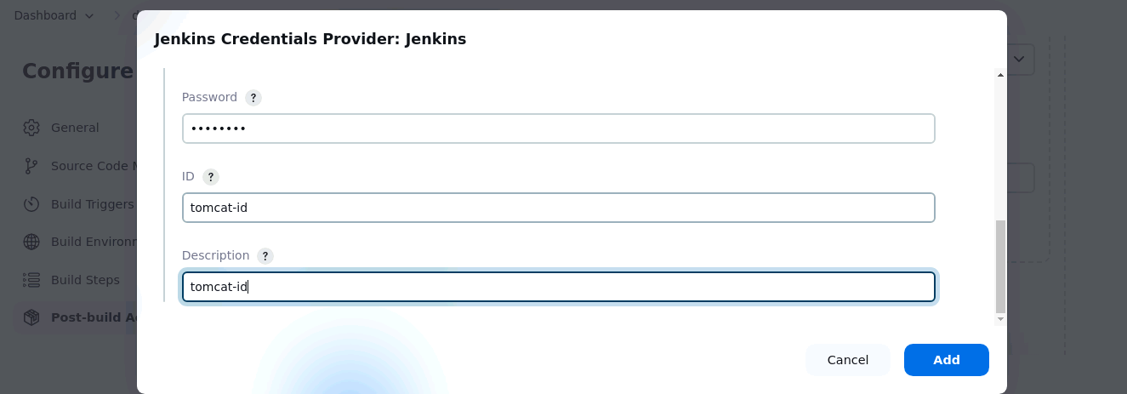
- Click on Add to save the credentials

- In the Credentials dropdown menu, select the added credentials

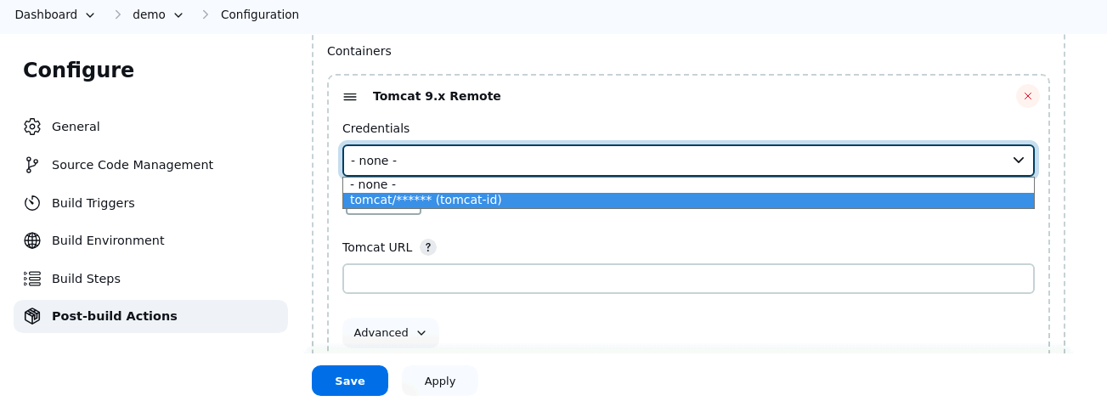

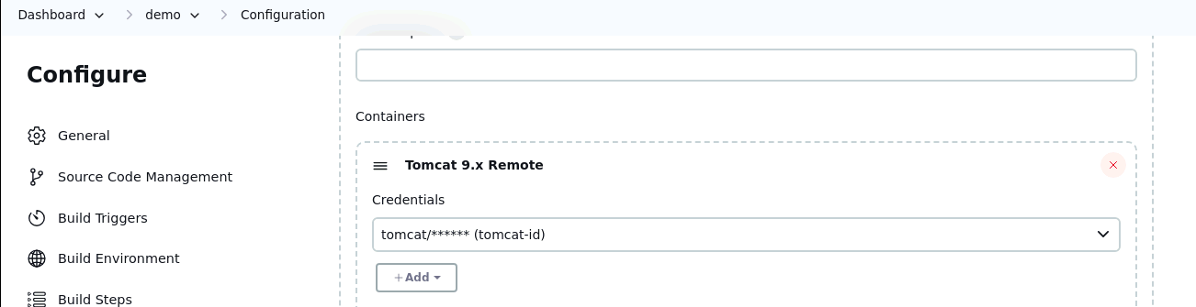

- Enter the following Tomcat URL and Save the job:
http://localhost:9090/
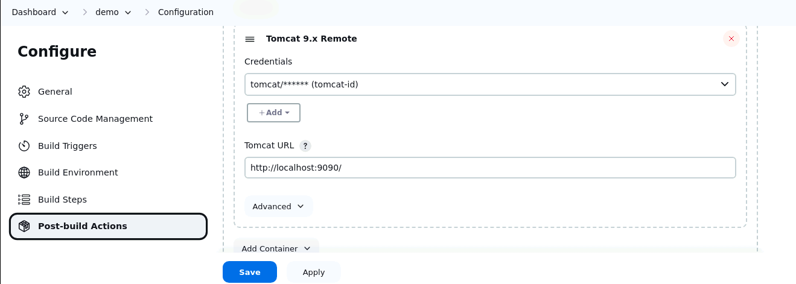

- Click on Build Now and then select Console Output to check the output

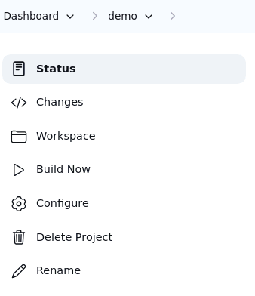

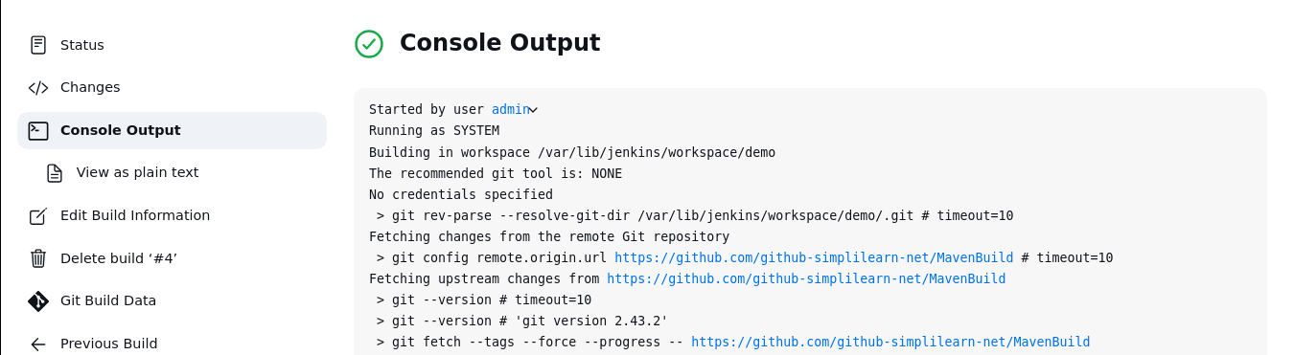

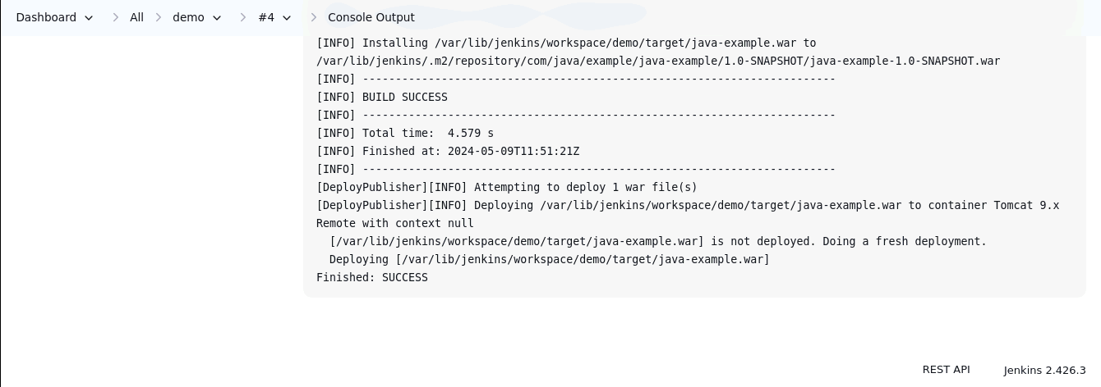

- Access the deployed application in your web browser with the following URL:
http://localhost:9090/java-example/
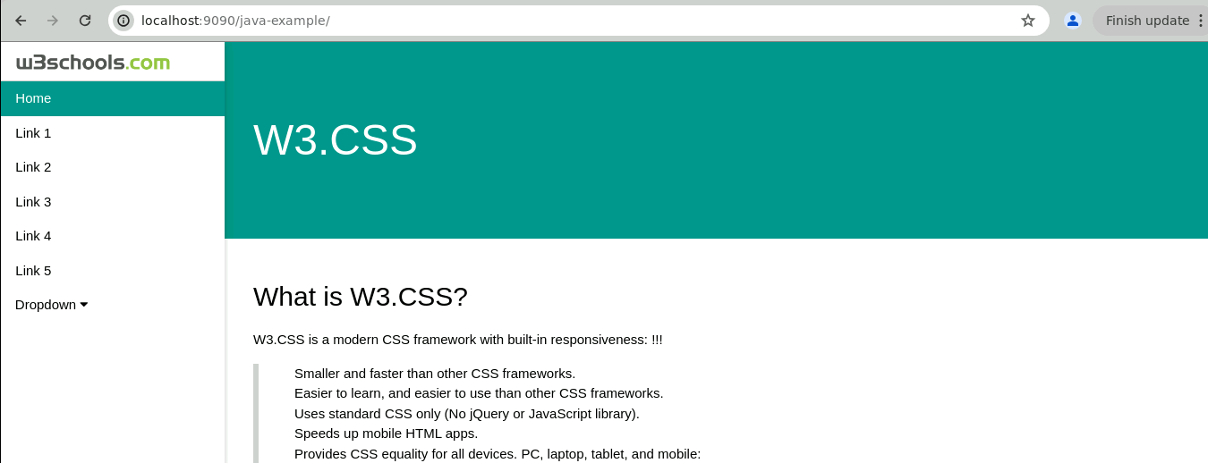

By following these steps, you have successfully configured a CI/CD pipeline in Jenkins for deploying a Java application to Apache Tomcat.

